**CSS Architecture – BEM – Lab**

Problems for exercises and homework for the ["CSS Advanced" course @ SoftUni](https://softuni.bg/trainings/3042/css-advanced-july-2020). Submit your homework in the SoftUni course instance page at <https://softuni.bg/trainings/2871/css-advanced-july-2020/>.

**Buttons – Design Guidelines**

Create a web page using the BEM methodology like the following:

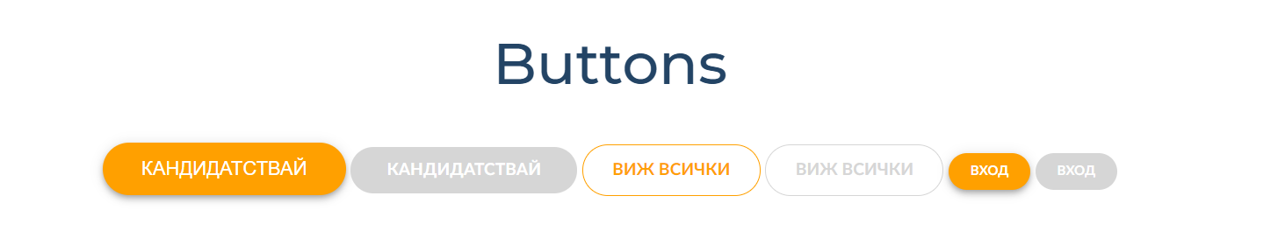

### Constraints

* Use the following design guideline: <https://zeroheight.com/646c17950/p/608bfb-button/b/32e1a2>

**Colors – Design Guidelines**

Create a web page using the BEM methodology like the following:

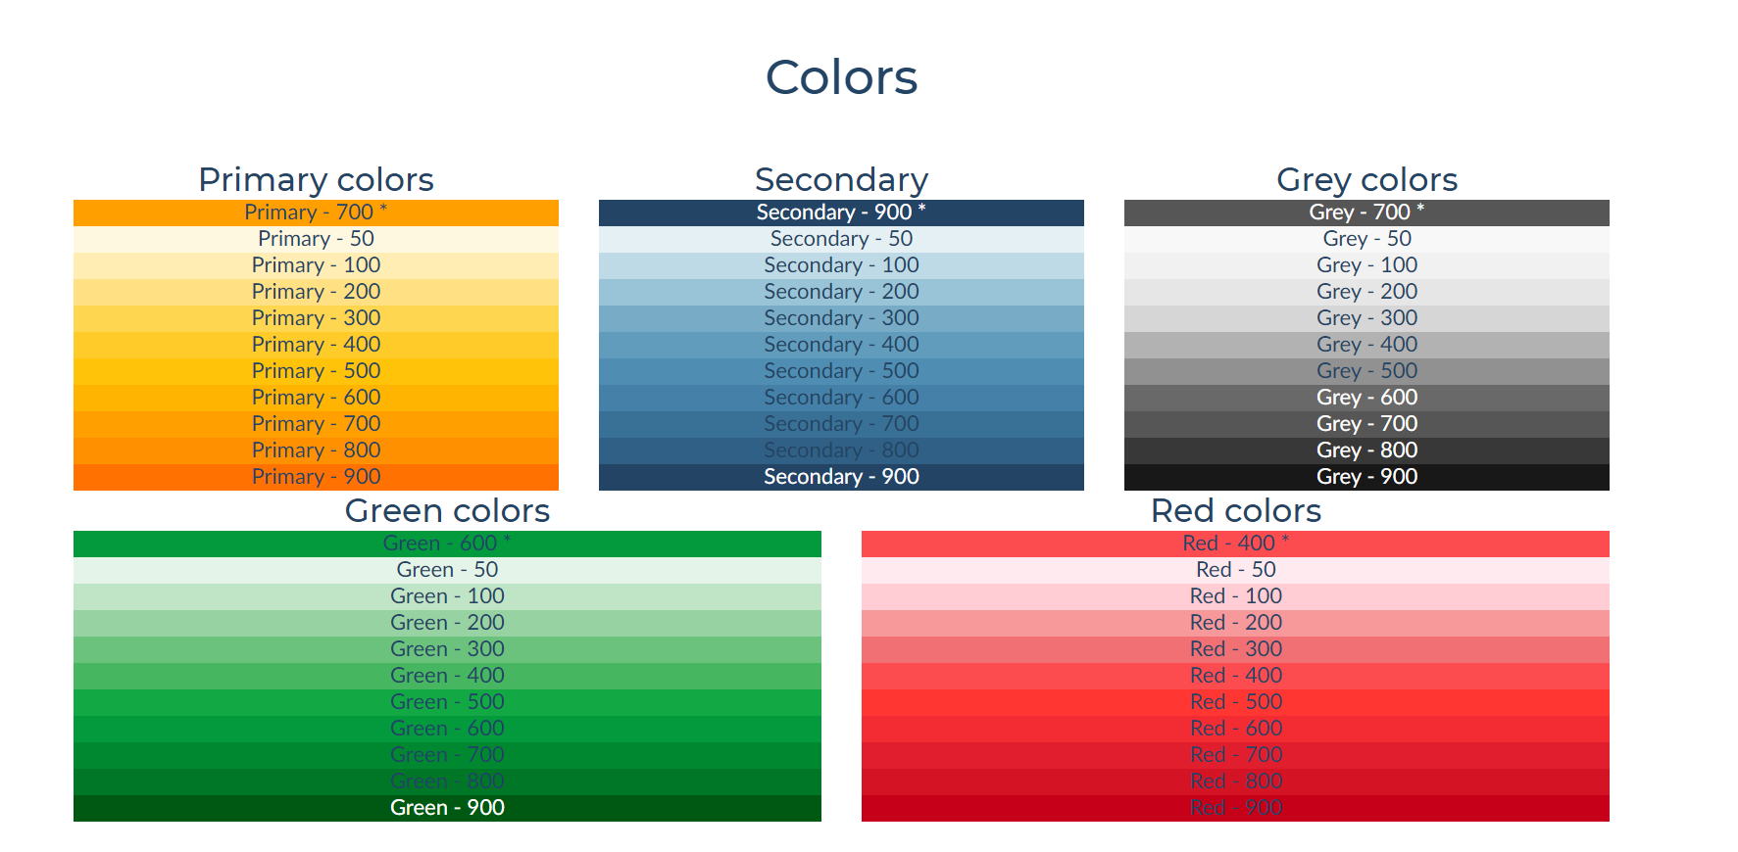

### Constraints

* Use the following design guideline: <https://zeroheight.com/646c17950/p/75e858-colors/b/2659b4>